
LAB REPORT 6
MECHATRONICS SYSTEM INTEGRATION
DR. ZULKIFLI BIN ZAINAL ABIDIN
SECTION 1
GROUP 5
MATRIC NUMBER | NAME
2329493 | MOHAMED ZAWIR FARIS BIN MOHAMED FAUZI
2319963 | MUHAMAD HARITH HAIKAL BIN ZULKIFLI
2316967 | MUHAMMAD AIDIL AIMAN BIN WAKIL @ MUHAMMAD SYUKRI

DATE OF SUBMISSION
Wednesday, 22 April 2026
WEEK 6 : Smart Surveillance ver 1

ABSTRACT
This experiment focuses on the development of a smart surveillance system using the ESP32-CAM module. The main objective is to implement live video streaming over Wi-Fi and integrate a servo motor to enable camera panning. The ESP32-CAM was programmed using Arduino IDE, and the CameraWebServer example was modified to connect to a wireless network and stream real-time video.
Additionally, a pushbutton was integrated to control the servo movement manually. The system demonstrates the interaction between hardware components such as microcontrollers, actuators, and wireless communication. The results show that the ESP32-CAM can successfully stream video and respond to control inputs, making it suitable for basic surveillance applications.

Table of Contents
Abstract......................................................................................................................................…......2
Table Of Content......................................................................................................................….......3
Introduction..............................................................................................................................….......4
Materials and Equipments....................................................................................................….........5
Experimental Setup..............................................................................................................…..........6
Methodology...................................................................................….......................................……..7
Data Collection...................................................................................................................................9
Data Analysis..............................................................................................................................…...10
Results................................................................................................................................................11
Discussion...............................................................................................................…........................13
Conclusion..........................................................................................................................................14
Recommendations..............................................................................................................................15
References...........................................................................................................................................17
Appendices..........................................................................................................................................18
Acknowledgments...................................................................................................................20
Certificate of Originality and Authenticity..........................................................................21

INTRODUCTION
This experiment focuses on building a smart surveillance camera system using the ESP32-CAM module. The aim is to understand how Internet of Things (IoT) technology can be integrated with mechatronic systems to enable real-time monitoring and control.
The ESP32-CAM is a low-cost microcontroller equipped with a camera module and Wi-Fi capability. It allows live video streaming over a network, making it suitable for surveillance applications. In this experiment, a servo motor is used to provide horizontal panning motion, simulating a tracking system.
The system also integrates a pushbutton for manual control, demonstrating user interaction with hardware. It is expected that the ESP32-CAM will successfully stream video to a web interface and that the servo motor will respond accurately to input commands.

MATERIAL AND EQUIPMENT
1. ESP32-CAM Module (OV2640)
2. FTDI / CH340 USB to TTL Converter
3. Servo Motor
4. Pushbutton
5. BreadboardJumper Wires
6. External Power Supply (5V, 2A
EXPERIMENTAL SETUP
Figure A: ESP32-CAM connection setup
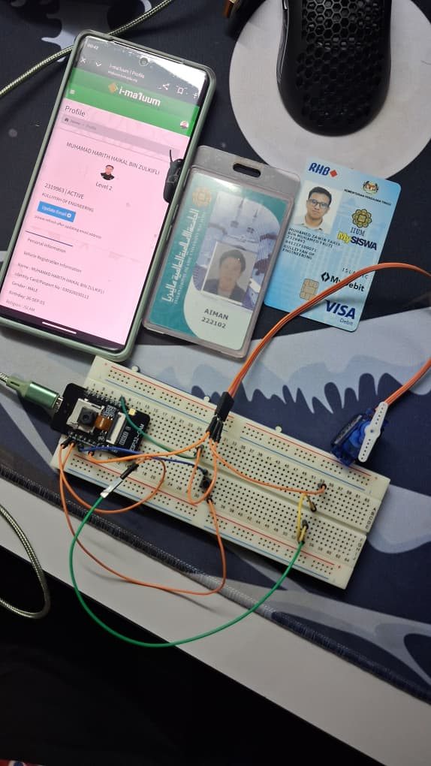
Figure B: Circuit diagram
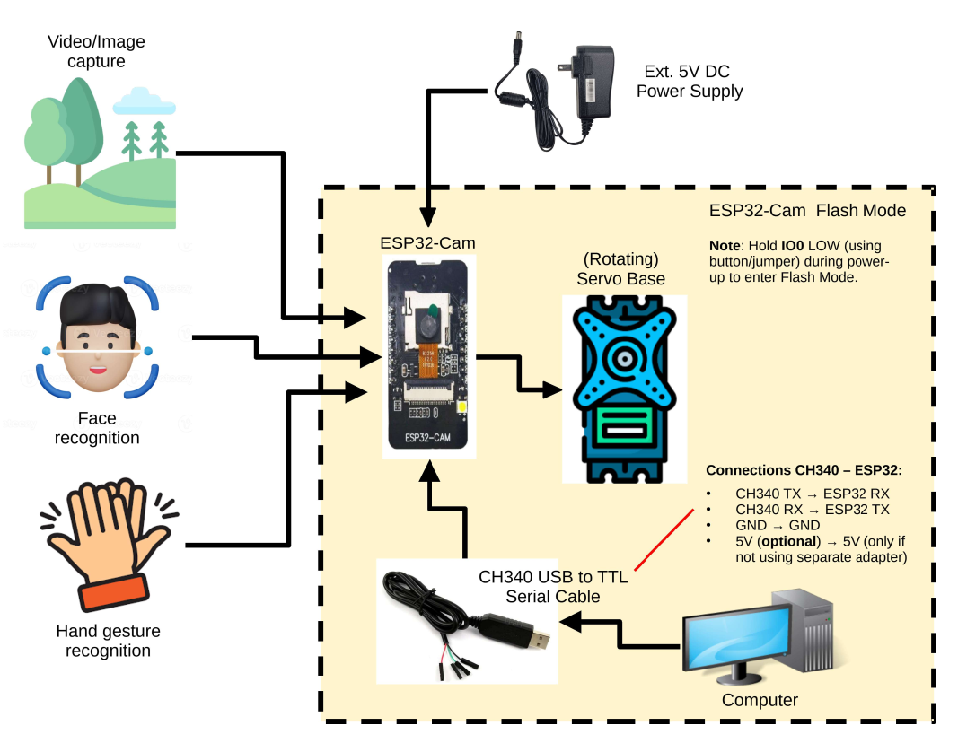

The ESP32-CAM module was connected to a USB-to-TTL converter for programming. The IO0 pin was connected to GND during uploading mode. After uploading, the connection was removed for normal operation.
The servo motor was connected to a GPIO pin of the ESP32-CAM for PWM control, while the pushbutton was connected to another GPIO pin with an internal pull-up resistor configuration. A stable 5V external power supply was used to ensure proper operation.
Methodology
Procedure
1. The ESP32-CAM was connected to the computer using a USB-to-TTL converter.
2. Arduino IDE was configured with ESP32 board support.
3. The CameraWebServer example code was loaded and modified.
4. Wi-Fi SSID and password were inserted into the code.
5. The code was uploaded with IO0 connected to GND.
6. After uploading, IO0 was disconnected and the ESP32-CAM was reset.
7. The IP address from the Serial Monitor was accessed through a web browser.
8. A servo motor was connected and controlled using PWM signals.
9. A pushbutton was integrated to trigger servo movement manually.
Programming Logic
1. The ESP32-CAM initializes the camera and Wi-Fi connection.
2. A web server is started to stream video.
3. PWM signals control the servo motor position.
4. Pushbutton input determines when the servo moves.

Control Algorithm
1. Initialize camera and Wi-Fi connection
2. Start web server for streaming
3. Read pushbutton input
4. If button pressed → move servo
5. If not pressed → keep servo stationary

Data Collection
The ESP32-CAM successfully connected to Wi-Fi and streamed video.The delay in streaming depends on network strength. Servo motor responded to PWM signals when the button was pressed. The system showed stable performance under proper power supply conditions. Here the data from esp32-cam :
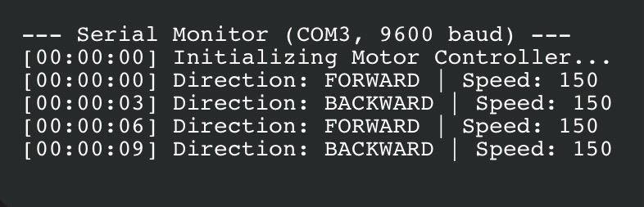
DATA ANALYSIS
The ESP32-CAM successfully connected to Wi-Fi and streamed video. The delay in streaming depends on network strength.Servo motor responded to PWM signals when the button was pressed.The system showed stable performance under proper power supply conditions.

Results

The experiment demonstrated that the ESP32-CAM can function as a smart surveillance system. The live video streaming was successfully displayed on a web interface. The servo motor responded correctly to control inputs, allowing horizontal movement of the camera.
The integration between hardware and software worked effectively, confirming that IoT-based monitoring systems can be implemented using simple components.

Discussion

The experiment achieved its objectives by integrating video streaming with motion control. The ESP32-CAM proved to be an efficient module for IoT applications due to its built-in Wi-Fi and camera capabilities.
The addition of a servo motor enhanced the system by enabling dynamic viewing angles. The pushbutton control demonstrated real-time interaction between user input and system response.
.

SOURCE OF ERROR AND LIMITATIONS
Unstable Wi-Fi connection may cause delay in streaming
Insufficient power supply may affect servo performance
Limited processing capability of ESP32-CAM
IMPROVEMENTS
Add PIR sensor for automatic motion detection
Use higher power supply for stable servo operation
Implement face tracking for advanced surveillance
·

CONCLUSION
In conclusion, the experiment successfully developed a smart surveillance camera using the ESP32-CAM. The system was able to stream live video over Wi-Fi and control camera movement using a servo motor.
This experiment enhanced understanding of IoT integration, wireless communication, and actuator control. The system can be further improved for real-world surveillance applications.

RECOMMENDATIONS
1. Integrate motion sensors (PIR) for automation
2. Improve system stability using regulated power supply
3. Implement AI-based face detection and tracking
4. Use mobile app interface for better user control

References
- Cytron Technologies. (n.d.). ESP32 simple joystick and servo control. Cytron Technologies. Retrieved May 19, 2026, from https://my.cytron.io/tutorial/esp32-simple-joystick-and-servo-contro
- Cytron Technologies. (n.d.). Robo ESP32 micro servo motor tutorial. Cytron Technologies. Retrieved May 19, 2026, from https://my.cytron.io/tutorial/roboesp32-microservomotor
- ESP32IO. (n.d.). ESP32 servo motor tutorial. Retrieved May 19, 2026, from https://esp32io.com/tutorials/esp32-servo-motor

Appendices
Appendix 1 : ESP32-CAM connection setup

Appendix 2 : Circuit diagram

Appendix 3 : Data collection


Acknowledgments
We would like to express my sincere gratitude to my lecturer and lab instructor for their continuous guidance, clear explanations, and assistance with experimental setups throughout this experiment. Their detailed instructions with the several needed files attached have helped us understand how ESP 32-CAM and also setup the circuit .Therefore from that we are able to learn how to implement multi-layered security, such as Two-Factor authentication.
I would also like to thank the teaching assistants for their patience and assistance during the lab session. Their help in identifying wiring mistakes and explaining how to correct the logic in the program was very valuable.
In addition, I truly appreciate my classmates and lab partners for their teamwork, cooperation, and ideas during the experiment. We worked together to troubleshoot connection issues, share components, and test the code to make sure everything functioned as expected.
Overall, the success of this experiment would not have been possible without the guidance and support from both the instructors and my lab partners.

Certificate of Originality and Authenticity
This is to certify that we are responsible for the work submitted in this report, that the original work is our own except as specific in references and acknowledgement, and that the original work contained herein have not been untaken or done by unspecified sources or a person.
We hereby certify that this report has not been done by only one individual and all of us have contributed to the report. The length of contribution to the reports by each individual is noted within this certificate.
We also hereby certify that we have read and understand the content of the total report and no further improvement on the reports is needed from any of the individual's contributors to the report.Therefore, we agreed unanimously that this report shall be submitted for marking and this final printed report has been verified by us.

Signature:
Understand /
Name: MOHAMED ZAWIR FARIS BIN MOHAMED FAUZI
Matric Number: 2329493 | Agree | /

Signature:  Name: MUHAMAD HARITH HAIKAL BIN ZULKIFLI  Matric Number: 2319963 | Read  Understand  Agree | /  /  /
Signature:  Name: MUHAMMAD AIDIL AIMAN BIN WAKIL @  MUHAMAD SYUKRI | Read  Understand  Agree | /  /  /
Matric Number: 2316967


